MINISTRY OF AGRICULTURE AND RURAL DEVELOPMENT
IRRIGATION PROJECTS CENTRAL PROJECT OFFICE
-----

MEKONG DELTA INTEGRATED CLIMATE RESILIENCE AND SUSTAINABLE LIVELIHOODS PROJECT

ETHNIC MINORITY DEVELOPMENT PLAN
(Draft)

SUBPROJECT 1: ADDRESSING COASTAL AND RIVERBANK EROSION IN MEKONG DELTA

KIEN GIANG PROVINCE

Kien Giang, 12/2019
MINISTRY OF AGRICULTURE AND RURAL DEVELOPMENT
IRRIGATION PROJECTS CENTRAL PROJECT OFFICE
----------------o00o---------------

MEKONG DELTA INTEGRATED CLIMATE RESILIENCE AND SUSTAINABLE LIVELIHOODS PROJECT

ETHNIC MINORITY DEVELOPMENT PLAN

SUBPROJECT 1: ADDRESSING COASTAL AND RIVERBANK EROSION IN MEKONG DELTA

KIEN GIANG PROVINCE

Kien Giang, 7/2020

MINISTRY OF AGRICULTURE AND RURAL DEVELOPMENT
IRRIGATION PROJECTS CENTRAL PROJECT OFFICE
----------------o00o---------------

MEKONG DELTA INTEGRATED CLIMATE RESILIENCE AND SUSTAINABLE LIVELIHOODS PROJECT

ETHNIC MINORITY DEVELOPMENT PLAN

SUBPROJECT 1: ADDRESSING COASTAL AND RIVERBANK EROSION IN MEKONG DELTA

KIEN GIANG PROVINCE

Project owner | Consultant

GLOSSARY
Project impacts | Means positive and negative impacts on EMs caused by all project components. Adverse impacts are often consequences immediately related to the taking of a parcel of land or to restrictions in the use of legally designated parks or protected areas. People directly affected by land acquisition may lose their home, farmland, property, business, or other means of livelihood. In other words, they lose their ownership, occupancy, or use rights, because of land acquisition or restriction of access.
Displaced (affected) people | Refers to individuals or organizations that are directly affected socially and economically by Bank-assisted investment projects caused by the involuntary taking of land and other assets that results in (i) relocation or loss of shelter; (ii) loss of assets or access to assets; or (iii) loss of income sources or means of livelihood, whether or not the affected persons must move to another location. The involuntary land acquisition includes the exercise of possession when the proprietor has allowed and benefited from others' occupation of the area. In addition, affected person is one for whom involuntary restriction of access to legally designated parks and protected areas that result in adverse impacts on livelihoods also.
Indigenous People | Equivalent to ethnic minority people in Viet Nam, refers to a distinct and vulnerable group with social and cultural characteristics in varying degrees as follows: (i) self-identification as members of a distinct indigenous cultural group and recognition of this identify by others; (ii) collective attachment to geographically distinct habitats or ancestral territories in the project area and to the natural resources in these habitats and territories; (iii) customary cultural, socio-economic ,or political institutions that are separate from those of the dominant society and culture; and (iv) an indigenous language, often different from the official language of the country or region.
Vulnerable groups | People who by virtue of gender, ethnicity, age, physical or mental disability, economic disadvantage, or social status may be more adversely affected by resettlement than others and who may be limited in their ability to claim or take advantage of resettlement assistance and related development benefits, include: (i) women headed household (single, widow, disabled husband) with dependents, (ii) disables (loss of working ability), the elderly alone, (iii) poor and near poor household, (iv) the landless, (v) ethnic minority groups and (vi) households policies.
Culturally appropriate | Means having regard to all aspects of the cultures, and being sensitive to their dynamics.
Free, prior and informed consultation | Refers to a culturally appropriate and collective decision-making process subsequent to meaningful and good faith consultation and informed participation regarding the preparation and implementation of the project. It does not constitute a veto right for individuals or groups.
Collective attachment | Means that for generations there has been a physical presence in and economic ties to lands and territories traditionally owned, or customarily used or occupied, by the group concerned, including areas that hold special significance for it, such as sacred sites. “Collective attachment” also refers to the attachment of transhumant/nomadic groups to the territory they use on a seasonal or cyclical basis.
Customary rights to lands and resources | Refers to patterns of long-standing community land and resource usage in accordance with Ethnic Minority Peoples’ customary laws, values, customs, and traditions, including seasonal or cyclical use, rather than formal legal title to land and resources issued by the State.
ABBREVIATIONS
AHs/APs | Affected people/Affected households
CPO | Irrigation Projects Central Management Office
ICRSL | Mekong Delta Integrated Climate Resilience and Sustainable Livelihoods Project
RAP | Resettlement Action Plan
MARD | Ministry of Agriculture and Rural Development
DARD | Department of Agriculture and Rural Development
WB | World Bank
PPC | Provincial People's Committee
PPMU | Provincial Project Management Unit
PC | People's Committee
IOL | Inventory of loss
DMS | Detailed measurement survey
VND | Vietnamese Dong
WB | Work Bank

TABLE OF CONTENT

I. INTRODUCTION 11
1.1. Background 11
1.2. Subproject 1: Addressing Coastal and Riverbank Erosion in Mekong Delta – Kien Giang province 12
1.3. Scope of EMDP 12
1.4. Objectives of EMDP 13
II. ETHNIC MINORITY POLICY FRAMEWORK 14
2.1. National Legal and Policy Framework for Ethnic Minority Peoples 14
2.2. World Bank’s Operational Policy on Indigenous Peoples (OP/BP 4.10) 16
III. DESCRIPTION OF THE SUBPROJECT POPULATION 17
3.1 Ethnic minority population in the subproject area 17
3.2 Socio – economic conditions of EM community in the 03 subprojectcommunes 17
IV. POTENTIAL IMPACT 21
4.1. Positive impacts 21
4.2. Negative impacts 22
4.3. Mitigation measures 23
V. CONSULTATION WITH ETHNIC MINORITY COMMUNITIES 24
5.1. Objectives of public consultations 24
5.2. Public consultation methods 24
4.2. Consultation results during the EMDP preparation 25
5.3. Public consultation during EMDP implementation 29
VI. ACTIVITIES PROPOSED FOR ETHNIC MINORITY PEOPLE 30
VII. INFORMATION DISCLOSURE AND DISSEMINATION 33
VIII. IMPLEMENTATION ARRANGEMENT 33
IX. GRIEVANCE REDRESS MECHANISM 34
X. MONITORING AND EVALUATION 36
10.1. Internal monitoring 36
10.2. External monitoring 37
XI. IMPLEMENTATION SCHEDULE AND BUDGET 37
11.1. Implementation schedule 37
11.2. Budget 38

LIST OF TABLES

Table 1: Statistics of location and length of each embankment section 12
Table 2: Legal Documents Relating to Ethnic Minority 15
Table 3: Socio-economic information of EM in the subproject communes 19
Table 4: Summary of negative impacts and relevant mitigation measures 23
Table 5: Consultations with EM communities 26
Table 6: Summary of proposed and activities and support activities 31
Table 7: Internal monitoring indicators 36
Table 8: External monitoring indicators 37
Table 9: Implementation schedule 38
Table 10: Cost estimate of EMDP 39

LIST OF ANNEXES
Annex 1: Minutes of consultation meetings for affected EM households 40
Annex 2: Project Information Booklet 56

EXECUTIVE SUMMARY
Project overview
- The Government of Vietnam has received a credit of the International Development Association (IDA) to finance the Mekong Delta Integrated Climate Resilience and Sustainable Livelihoods Project (MD-ICRSL Project). The Project has started since the third quarter of 2016 with the development objective of "Strengthening tools for planning and adapting to climate change and improving resilience to climate change for land and water resource management in the selected provinces in the Mekong Delta". Subproject 01: "Addressing Coastal and Riverbank Erosion in Mekong Delta - Kien Giang Province" is part of Component 2 - Managing Upstream Floods - Mekong Delta Integrated Climate Resilience and Sustainable Livelihoods Project (MD-ICRSL Project).
- Subproject 1: "Addressing Coastal and Riverbank Erosion in Mekong Delta - Kien Giang Province" is proposed to build an "Embankment against landslides in Xeo Nhau area, An Minh district". The work will cover 03 communes: Tan Thanh, Dong Hung A and Van Khanh Dong, in An Minh district, where there are ethnic minorities (Khmer people) who are temporarily affected by the construction of the work.
Objectives of the Ethnic Minority Development Plan
- This Ethnic Minority Development Plan (EMDP) is prepared for the work-item "Embankment against landslides in Xeo Nhau area, An Minh district". Affected ethnic minorities (EM) in the subproject area live in 03 communes (Tan Thanh, Dong Hung A, and Van Khanh Dong), who are mainly Khmer people. Specifically, the construction of the work-item will temporarily affect four ethnic minority households.
- This EMDP aims to: (a) summarize the potential impacts of the project on ethnic minorities and mitigation measures (if needed), (b) propose development activities that need to be implemented to ensure that EM people in the project area receive their socio-economic benefits that are appropriate to their culture.
Positive and negative impacts
Positive impacts:
- Subproject 01 will conduct erosion repair in Xeo Nhau area and An Minh area. The embankment will directly protect 3,106 people and indirectly protect 14,319 people. Expectedly, about 493.5 ha of forest area are protected and 220 ha of forest will be restored; about 286 ha of productive land is directly protected and 4,025.5 ha of forest land is indirectly protected. In addition, important infrastructure works will be upgraded like protection forests, sea dikes, infrastructure systems inside sea dykes and houses.
Negative impacts:
- According to the IOL results (conducted in November 2019), the subproject construction does not cause permanent impacts on land acquisition because the subproject construction is entirely at sea. During the subproject construction, it will temporarily affect aquaculture and fishing activities of 04 ethnic minority households (Khmer households) with the total aquaculture area of ​​7,500m2. This land area is leased by households from the Commune People's Committees. No household is severely affected. No household is required to be relocated. In addition to temporary impacts related to land acquisition, people in the subproject area, including ethnic minorities, will be subject to potential impacts during construction, which are determined as follows:
- Potentially temporary impacts on households' livelihoods and incomes: land and fishing activities.
- Impacts on waterway traffic during construction.
- Social evils due to the increase of labor influx to the subproject area.
- Mitigation measures: Support compensation for aquaculture products of households to be affected (if needed) or cash allowance for temporary impact to EM production activities; raise public awareness about water traffic safety; prevent social evils during the construction period; and ensure the contractors take measures to transport materials and restore affected infrastructure works to status quo.
- Legal Framework of EMDP. The legal framework and policies for preparation and implementation of this EMDP is based on the relevant laws, decrees and circulars of the Government of Vietnam (GOV) for the minority communities and in compliance with the policy on Indigenous Peoples (OP/BP 4.10) of the World Bank (WB) and on the approved Ethnic Minority Policy Framework (EMPF) for the project.
- Gender. The social assessment results show that with regards to public services access, there is no discrimination or obstruction to men or women in their access to healthcare, education as well as social and cultural institutions, but the tradition bars female family members’ right to inherit land, therefore women’s accessibility to this important asset is denied.
- Information disclosure and public consultation. The public consultation with the EM communities in the subproject area was conducted in November 2019 to assess impacts on livelihoods and determine action/mitigation measures to meet the needs of the communities. The consultation results are incorporated in this EMDP. The process of consultation and information disclosure will be continued during the subproject implementation. The consultations with the EM communities are also combined with the information about the benefits brought by the subproject and adverse impacts that negatively affect people in the subproject area. The EM communities in the subproject area confirmed their broad support to the subproject implementation.
- Implementation arrangement. The Ministry of Agriculture and Rural Development is the governing body of the ICRSL project, on behalf of the Government, which is responsible for the general management of the ICRSL project. The People's Committees of the project provinces are the project owners of the subprojects in the project respective provinces, which are responsible for deciding investment in the subprojects managed by the Ministry of Agriculture and Rural Development and the provinces. In addition, a Project Steering Committee has been established for the ICRSL project, which is composed of representatives of the Ministry of Agriculture and Rural Development of the relevant ministries. The People's Committees of the project provinces shall regularly monitor and administer the subprojects during the implementation process. A Central Project Management Unit (CPMU) has been established under the CPO to coordinate policy and strategic issues, providing comprehensive guidance and assistance in coordination. The CPMU is generally responsible for the implementation of the prepared EMDPs under the Project. In addition, the CPMU is responsible for ensuring effective implementation of the EMDP, including monitoring and evaluating the results of the EMDP implementation. The Provincial Project Management Unit (PPMU) and local authorities shall prepare and implement the EMDPs, ensuring that the human resources and budget are appropriate and sufficient to meet the objectives of the EMDP.
- Grievance Redress Mechanism. The grievance redress mechanism for EM people will be the same as the grievance redress mechanism established for the whole project. However, if local leaders could provide support or guidance for conflict resolution, these traditional procedures for these cases would be taken into account.
- Monitoring and evaluation. The implementation of the EMDP will be monitored and guided on a frequent basis by the PPMU. The independent monitoring reports of EMDP implementation will be submitted in biannual basis to the World Bank.
- Activities proposed. To ensure the EMs' benefits from the subproject, it is expected to boost the farming activities and business, and training courses will be designed (i) to be accessible and culturally appropriate for EM peoples; and (ii) to support EM’s participation to reach at least 30% of local EM’s participants in training courses and public consultations.
- Budget. The EMDP will be implemented as an independent program. The main cost estimation for the EMDP implementation is VND 108,000,000, equivalent to US$ 4,645.16 (exchange rate: USD 01 = VND 23,250). The compensation and assistance costs for temporary impacts on livelihoods are included in the total project cost.

INTRODUCTION

Background
- The Government of Vietnam has received a credit of the International Development Association (IDA) to finance the Mekong Delta Integrated Climate Resilience and Sustainable Livelihoods Project (MD-ICRSL Project). The Project has started since the third quarter of 2016 with the development objective of "Strengthening tools for planning and adapting to climate change and improving resilience to climate change for land and water resource management in the selected provinces in the Mekong Delta". The total investment of the Project is USD 385.9 million (USD 310 million is financed by the IDA; USD 72.5 million is financed by the Government's counterpart fund; and USD 2.4 million is from private capital). The Project is designed with 05 components as follows.
- Component I: Enhancing monitoring, analytics, and information systems (USD 61.29 million): Component I focuses on overcoming the shortage of databases, synchronizing documents and optimizing the use of databases in the direction of policy and coordination administration and planning, especially operating irrigation systems to serve production and people's life in order to minimize adverse impacts caused by climate change.
- Component II: Managing Floods in the Upper Delta (USD 100.909 million): The main objective of this Component is to protect and enhance positive effects of floods via flood control measures (flood water retention), increase rural incomes, and protect high value assets. It is possible to use (i) flood control measures (flood water retention) which is more beneficial in rural areas and provide alternatives in agricultural and fishery production; (ii) provide livelihood supports to farmers so that they can replace rice crops in flood seasons, including aquaculture; (iii) build and upgrade infrastructure to protect high-value assets like urban areas and orchards, and support the efficient use of agricultural water in dry seasons.
- Component III: Adapting to Salinity Transitions in the Delta Estuary (107.075 million USD): The main objective of this Component is to address challenges relating to saline intrusion, coastal landslides, sustainable aquaculture and livelihood improvement for coastal communities. The activities will include: (i) Construction of coastal protection systems such as embankments, dykes and mangrove forests; (ii) upgrading irrigation and agricultural infrastructure along coastal areas to increase aquaculture flexibility and sustainability and adapt to salinity change; (iii) support farmers to convert (if needed) to more sustainable brackish water farming activities such as mangrove-shrimp, rice-shrimp, and other aquaculture activities; and (iv) support the smart agriculture to adapt to climate change by facilitating effective water use in dry seasons.
- Component IV: Protection of coastal areas in the delta peninsula (USD 101.148 million): The activities include (i) Construction/rehabilitation of coastal protection forest belts in combination with embankments, dykes and mangrove forest belts; (ii) upgrading infrastructure to control tidal and saline water along coastal areas to help the aquaculture to be flexible and sustainable; (iv) controlling groundwater resources used for agriculture/fisheries and developing freshwater sources for domestic use; (v) supporting farmers to implement more sustainable brackish water farming activities such as mangrove forests - organic shrimp and other fisheries activities; and (vi) support the smart agriculture to adapt to climate change and effective use of water.
- Component V: Support for project management and implementation (USD 14.557 million): This component is divided into project management support and capacity building for MONRE/MARD/MPI and project participating provinces. It will support the increased costs associated with project management and provide consulting services for overall project management, financial management, bidding, safeguard policies and evaluation monitoring.

Subproject 1: Addressing Coastal and Riverbank Erosion in Mekong Delta – Kien Giang province
- General objectives: Preventing erosion of river and coastal banks, protecting coastal population, infrastructure and land, enabling livelihoods stabilization and development, and improving incomes for people in the subproject area.
- Specific objectives: Stopping erosion at selected critical (emergency) locations, promoting land and water management better and improving disaster resilience under climate change and sea level rise conditions in selected provinces in the Mekong Delta.
- Subproject 1: "Addressing Coastal and Riverbank Erosion in Mekong Delta - Kien Giang Province" is proposed to build an "Embankment against landslides in Xeo Nhau area, An Minh district". The work will covers 03 communes: Tan Thanh, Dong Hung A and Van Khanh Dong, in An Minh district. The regional erosion speed is typical at 15-20m/year and in some sections, it can be 40-50m/year in the years when there are big waves. Costal lines are increasingly seriously eroded into land and sea dykes. Serious landslides affect populous residential areas, office headquarters, important infrastructures and cause land loss and serious degradation of coastal mangroves.
- According to preliminary estimates, the "Embankment against landslides in Xeo Nhau area, An Minh district" will directly protect 3,106 people and indirectly protect 14,319 people. Expectedly, about 493.5 ha of forest area are protected and 220 ha of forest will be restored; about 286 ha of productive land is directly protected and 4,025.5 ha of forest land is indirectly protected. In addition, important infrastructure works will be upgraded like protection forests, sea dikes, infrastructure systems inside sea dykes and houses, maintenance of the environment and support livelihoods for people.

Scope of EMDP
- Subproject 1: "Addressing Coastal and Riverbank Erosion in Mekong Delta - Kien Giang Province" is proposed to build an "Embankment against landslides in Xeo Nhau area, An Minh district". The subproject implementation will affect temporary land acquisition for EM people in the subproject area.
Table 1: Statistics of location and length of each embankment section
No. | Names of embankment sections | Length (km) | Locations
II | Xeo Nhau - Muong Dao canals | 9.8 km
II-1 | Xeo Nhau - Xeo La canals | 1.8 | Tan Thanh, An Minh district
II-2 | Xeo La – Thuong Luong canals | 1.3 | Tan Thanh, An Minh district
II-3 | Ro Ghe – Xeo Doi canals | 1.3 | Dong Hung A, An Minh district
II-4 | Xeo Doi – Chu Vang canals | 1.7 | Van Khanh Dong, An Minh district
II-5 | Chu Vang – Muoi Than canals | 3.0 | Van Khanh Dong, An Minh district
II-6 | Muoi Than Muong Dao canals | 0.7 | Van Khanh Dong, An Minh district
(Source: Project proposal, 10/2018)
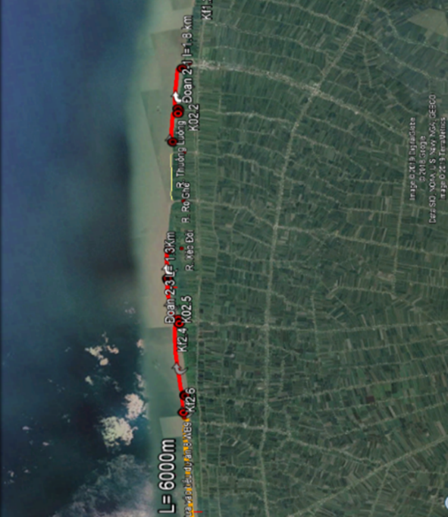 | 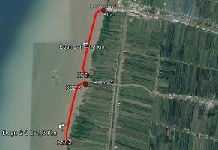
Construction area | Location of embankment II -1 and II - 2
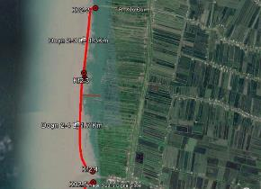 | 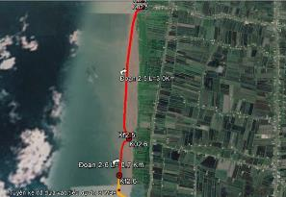
Location of embankment II-3 and II-4 | Location of embankment II-5 và II-6

Objectives of EMDP
- The Ethnic Minority Development Plan is prepared in accordance with the World Bank’s OP/BP 4.10 policy on Indigenous Peoples and the approved EMPF. This plan is prepared based on social assessment (SA) carried out for the project and consultation with EM people in the subproject area.
- The objectives of this EMDP are to
- Identify measures for mitigating negative impacts on the EM community, and maximize the benefits of the project by selecting the most suitable design alternative
- Propose development activities in need to ensure that EM people in the project area receive socio-economic benefits appropriate to their culture of gender and multi-generation through training and livelihood improvement activities. Development activities displayed below are proposed after thoroughly consulting with EM peoples and outputs of the Project’s social assessments.

ETHNIC MINORITY POLICY FRAMEWORK

National Legal and Policy Framework for Ethnic Minority Peoples
- The Constitution of the Socialist Republic of Vietnam (2013) recognized the equality among the ethnic groups in Vietnam. Article 5 of the Constitution in 2013 provides that:
- The Socialist Republic of Vietnam is the unified State of all nationalities living together in the country of Vietnam.
- The nationalities equal, unite, respect and help each other to develop; prohibits any discrimination, ethnic division.
- The national language is Vietnamese. Every ethnic group has the right to use its own language and system of writing, to preserve its national identity, to promote its fine customs, habits, traditions and culture.
- The State implements a policy of comprehensive development, and provides conditions for the ethnic minorities to promote their physical and spiritual abilities and to develop together with the nation.
- The Socio-Economic Development Plan and the Socio-Economic Development Strategy of Vietnam specifically call for attention to ethnic minorities. Major programs targeting ethnic minority people include Program 135 (infrastructure in poor and remote areas) and Program 134 (eradication of poor-quality houses). A policy on education and health care for ethnic minorities is in place. The legal framework was updated in 2014.
- The Government of Vietnam has developed a series of policies to develop, enhance socio-economic condition of ethnic minorities in the mountainous and remote regions. After the programs 124, 125 for the phase 1, 2, the GoV launched the program 135 for the phase 3 to accelerate socio-economic development in communes, villages, especially particularly difficult areas and ethnic and mountainous regions. Besides the overall development program for ethnic minorities, the Government assigned the Committee for Ethnic Minorities Affairs to guide provinces to prepare projects Development Assistance for ethnic groups with less than 1,000 people, i.e. Si La, Pu Peo, Ro Mam, Brau, O Du. The Government also conducted Rapid and Sustainable Pro-poor Program for 61 poor districts, where many ethnic minorities live.
- The Prime Minister promulgated Decree No.84/2012/ND-CP dated 12 October, 2012 on the functions, tasks, powers and organizational structure of the Committee for Ethnic Minorities Affairs (CEMA). The Decree stipulated that the CEMA, a ministerial government, performs the function of state management of ethnic affairs in the country; state management of public services under the jurisdiction of CEMA as stipulated by law. Along with Decree No.05/2011/ND-CP dated 14 January, 2011 on the work of EM, Decree No.84/2012/ND-CP was issued as a legal basis for CEMA to continue concretizing guidelines and policies of the State on ethnic minorities in the period of industrialization and modernization; promote the power to unite the whole nation for the target rich people, strong country, social justice, democracy and civilization, in order to ensure and promote equality, solidarity, respect, help each other to develop and preserve the cultural identity of the peoples in the great family of ethnic groups of Vietnam.
- The documents of the Government based on democracy and the participation of local people are directly related to this EMPF. Ordinance No.34/2007/PL-UBTVQH11, dated 20 April, 2007 (replaced for Decree 79/2003/ND-CP dated 07 July, 2003) on the implementation of democracy in communes, wards, and town provides the basis for community involvement in the preparation of development plans and supervision of community in Vietnam. Decision No.80/2005/QD-TTg by the Prime Minister, dated 18 April, 2005 regulates the monitoring of community investments. Legal Education Program of CEMA (2013 - 2016) aims to improve the quality and effectiveness of legal education, awareness rising on self-discipline, respect, strictly abiding law of officials and public servants, and the workers of the organizations for EM.
- The Land Law in 2013 affirms that land belongs to all peoples, with the State representing on behalf of all peoples the ownership and management of this land. The State authorizes the land use rights to the land users through land allocation, land lease, recognition and management of land use. For the allocation of forestland, the Land Law provides that allocation of production forestland, protection forestland, special use forestland for organizations, households, individuals, community; however, each type of forestland allocated for different user has different rights. Those being allocated by the State are called “land users”. Land Law prescribes that land users are issued with land use certificates, entitled to products from the investment on the land. Households, individuals allocated by the State for production plantation land have the right to transfer, convert, lease, inherit, mortgage and joint venture the value of the land area; forest allocated communities are not able to transfer, convert, lease, inherit, mortgage and joint venture the value of the land area.
- The development of socio-economic policies for each region and target group should consider the needs of EMs. Socio-economic development plan and strategy of Vietnam calls for special attention to ethnic minorities. Policies on education and health care for ethnic minorities have also been issued. The legal framework was updated in 2014. All legal documents related to EM are shown in Table 3.
Table 2: Legal Documents Relating to Ethnic Minority
2016 | Decision No.2085/QD-TTg by the Prime Minister on approval the Special policy to support socio-economic development in ethnic minority and mountainous areas in the period of 2017 – 2020.
2015 | Decision No.1557/QD-TTg dated 10/09/2015 of the Prime Minister on the approval of a number of indicators for the Millennium Development Goals for ethnic minority associated with sustainable development goals after 2015.
2013 | Decision No.29/2013/QD-TTg dated May 20, 2013 of the Prime Minister  on a number of policies to support the settlement of residential land and employment for poor and difficult ethnic minorities in the Mekong Delta in the period of 2013 - 2015.
2013 | Decision No. 449/QD-TTg dated March 12, 2013 of the Prime Minister approving the Strategy of Ethnic Minority Affairs by 2020.
2013 | Decision No. 2356/QD-TTg dated December 4, 2013 of the Prime Minister promulgating the Action Program for Ethnic Work Strategy Implementation to 2020.
2013 | Joint Circular No.05/2013-TTLT-CEM-ARD-MPI-TC-XD dated on November 18, 2013 guideline of program 135 on support infrastructure investments, production development for extremely difficult communes, border communes, particularly difficult villages.
2012 | Decision No.54/2012-QD-TTg of the Prime Minister dated on December 04, 2012 on promulgation of lending policy for development for particularly difficult ethnic minorities in period 2012-2015.
2012 | Decree No.84/2012/ND-CP of the Government dated on December 10, 2012 on functions, tasks, powers and organizational structure of the Committee for Ethnic Minorities.
2012 | Joint Circular No.01/2012/TTLT-BTP-CEM date on January 17, 2012 of the Ministry of Justice and the Committee for Ethnic Minorities on guideline and legal assistance for ethnic minorities.
2010 | Decree No.82/2010/ND-CP of government, dated 20 July 2010 on teaching and learning of ethnic minority languages in schools.
2009 | Decision No.102/2009/QD-TTg dated on August 07, 2009 of the Prime Minister on directly policy assistance for the poor in difficult area.
2008 | Resolution No.30a/2008/NQ-CP of government, dated 27 Dec. 2008 on support program for rapid and sustainable poverty reduction for 61 poorest districts.
2007 | Circular No.06 dated 20-September-2007 of the Committee for Ethnic Minorities Affair guidance on the assistance for services, improved livelihood of people, technical assistance for improving the knowledge on the laws according the decision 112/2007/QD-TTg.
2007 | Decision No.05/2007/QD-UBDT dated 06-September-2007 of the Committee for Ethnic Minorities Affair on its acceptance for three regions of ethnic minorities and mountainous areas based on development status.
2007 | Decision No.01/2007/QD-UBDT dated 31-May-2007 of the Committee for Ethnic Minorities Affair on the recognition of communes, districts in the mountainous areas.
2007 | Decision No.06/2007/QD-UBDT dated 12-January-2007 of the Committee for Ethnic Minorities Affair on the strategy of media for the program 135-phase 2.

World Bank’s Operational Policy on Indigenous Peoples (OP/BP 4.10)
- The OP/BP 4.10 policy aims at limiting effect factors, adverse impacts on indigenous people and increase activities to bring about project benefits and their traditional cultural values. WB requires indigenous peoples (i.e. ethnic minority people) to be fully informed and able to freely participate in projects. The project has to be widely supported by the affected EMs. Besides, the project is designed to ensure that the EMs are not affected by negative impacts during the development process, especially impacts of the projects funded by the WB and that the EM peoples should be ensured to receive socio-economic benefits that should be culturally appropriate to them. The Policy defines that EMs can be identified in particular geographical areas and the following characteristics at different levels:
- Self-close attachment as members of distinct indigenous cultural group and recognition of this identity by others;
- Collective attachment to geographically distinct habitats or ancestral territories in the project area ad close to natural resources in these habitats and territories;
- Customary cultural, economic, social, or political institutions that are separate from those of the dominant society and culture; and
- Speak an indigenous language, often different from the official language of the country or region.
- As a prerequisite for an investment project approval, OP/BP 4.10 requires the Borrower to conduct free, prior and informed consultations with potentially affected EM peoples and to establish a pattern of broad community support for the project and its objectives and the project activities. It is important to note that the OP/BP 4.10 refers to social groups and communities, and not to individuals. The primary objectives of OP 4.10 are to ensure that:
- Such groups are afforded meaningful opportunities to participate in planning project activities that affects them;
- Opportunities to provide such groups with culturally appropriate benefits are considered; and
- Any project impacts that adversely affect them are avoided or otherwise minimized and mitigated.
- In the subproject context, the EM groups in the subproject area are likely to receive long-term benefits through repairing, construction of transport and irrigation works, however, their cultural and social lives in the subproject area and adjacent locations during the subproject implementation process may be negatively affected.

DESCRIPTION OF THE SUBPROJECT POPULATION

Ethnic minority population in the subproject area
- Kien Giang is a coastal province in the Mekong Delta region of the South of Vietnam. The North of Kien Giang borders Cambodia, the South borders Bac Lieu and Ca Mau provinces, the West borders the Gulf of Thailand, and the East is bounded by the respective provinces of An Giang, Hau Giang and Can Tho city. The whole province has 15 cities/districts with the total natural area of ​​634,878.42 ha. In particular, the area of ​​agricultural land is 570,634.25 ha (89.9%), the area of ​​non-agricultural land is 61,870.3 ha (9.7%), and the area of unused land2,373.9 ha.
- The province's average population in 2018 was estimated at 1,810,454 people, an increase of 17,905 people compared to 2017 (1%). The urban population was estimated 528,492 people, accounting for 29.19%. The rural population was estimated 1,281,962 people, accounting for 70.81%. The male population accounts for 903,719 people, accounting for 49.92%. The female population accounts for 906,735, accounting for 50.08%. The population density of the whole province is 285 people/Km2.
- The province's labor force aged 15 years old and above in 2018 was estimated at 1,146,312 people, an increase of 17,972 people compared to 2017. In particular, male laborers are 684,463 persons, accounting for 59.7%; female laborers are 461,849 people, accounting for 40.29%. The labor force aged 15 years old and above in urban areas included 327,845 persons, accounting for 28.6%, while in rural area is 818,467 people (71.4%). The unemployment rate of working age in 2018 was 2.97%, in which urban areas accounted for 2.71% and rural areas accounted for 3.07%.
- The total gross product in the area at current prices in 2018 reached VND 87,356.53 billion, of which the agriculture accounted for 35.7%, the industry - construction accounted for 19.26%, and the services accounted for 41.72%. The average income per person per month (in 2018) is 3,779 million/person/month.
- Regarding ethnicity and religion, Kien Giang is home to more than 15 different ethnic groups. The Kinh make up 85.5% and the Khmer make up 13.4% of the population (56,782 households with 24,602 people), who concentrate in Chau Thanh and Go Quao districts. The Chinese make up about 2.2% of the population and mainly live in Rach Gia city and Chau Thanh district. Other ethnic groups are Cham, Tay, Muong, Nung .... The poverty rate among the ethnic minorities decreased from 17.6% in 2015 to 7.29% at the end of 2018 and 7 out of 9 communes have been out of the list of extremely difficult communes under Program 135. Among the different ethnic groups, the Khmer is the poorest and most vulnerable group, followed by the Cham while the Hoa have an equal standing with the Kinh.
- The percentage of households using hygienic water in the whole province is 86.02%. The rate of multi-dimensional poor households of Kien Giang is 4.14%. In particular, the poverty rate in urban areas is 1.96% and in rural areas is 4.95%. The proportion of urban population provided with clean water through centralized water supply systems is 85.4%.

Socio – economic conditions of EM community in the 03 subproject communes
- The work will cover 03 communes: Tan Thanh, Dong Hung A and Van Khanh Dong, in An Minh district, where there are ethnic minorities (Khmer people) who are temporarily affected by the construction of the work.
- According to the initial screening, the subproject implementation temporarily affected coastal fishing activities (difficulty in moving to the fishing area due to further offshore fishing during construction) and coastal aquaculture of 04 ethnic minority households in the area. In addition, the construction may cause negative impacts on cultural and social life of ethnic minority communities in adjacent areas. The following section discusses the socio-cultural characteristics of ethnic minority groups which were consulted.
- The Khmer ethnic group is one of the 54 ethnic groups living and developing in Vietnam’s territory. Ethnic Khmer lives mainly in the Mekong Delta, with an average population of about 1,183,476 people, accounting for 93.9% of the total Khmer population in the country.
- Population: According to the statistics in 2019, Khmer people account for 13.4% of the population (56,782 households with 24,602 people) in Kien Giang. They mainly live in the districts: Chau Thanh, Go Quao, Hon Dat, An Bien, Kien Luong, and Giong Gieng. The population scale is 4.9 people/household which is quite higher than other ethnic groups in the country. The number of dependents is large with the dependency ratio of about 44.3% (of which the child dependency rate is 37 % and the old dependency rate is 7.3%). Khmer ethnic group in Kien Giang accounts for 17.82% of the total Khmer population in the Mekong Delta.
- The total population of the three communes is about 27.4 thousand people with 7,287 households, of which, males account for 50.3% of the total population (13,845 people). The labor force of the subproject communes is about 14,912 people. The population density in Tan Thanh commune is 251 people/km2, Dong Hung A commune is 214 people/km2 and in Van Khanh Dong commune is 206 people/km2. The average income per capita in the subproject area is 22-25 million/person/year. The main occupation of the households in the subproject area is aquaculture and fishing (or agriculture). In the off-season time, people will work as hired laborers and men work as masons to improve household income.
- In the subproject area (Tan Thanh, Dong Hung A and Van Khanh Dong Commune), Khmer people account for a small proportion (2.4% of the total households living in 3 project communes). Specifically, Tan Thanh commune has 51 ethnic minority households including 34 EMHHs is poor HHs (accounting for 7.5% of poor HHs in whole commune (411 poor HH in Tan Thanh commune) and Dong Hung A commune has 65 ethnic minority households, Van Khanh Dong commune has 60 ethnic minority households.
- The main ethnic minority in 03 communes are Kinh and Khmer. Khmer people live integrated with Kinh people and have good relationship with each other. They live in harmony and well together, learning from each other about the experience of production. In the same schools, there are both Khmer students and Kinh student. In meeting of hamlet or commune organization ethnic minority people and Kinh people join together.
- Characteristics of household members: According to the socio-economic report of communes, and in-dept interview with local people, the average household’s structure of ethnic minority households are 4.0 people/HHs (from 3-5 people/ per household inducing parent and children). Some households have 3-4 generations living together. The Khmer in commune got married in the same locality, or same communes.
- Language: Khmer people have their own language: Mon - Khmer. However, in the subproject, they can use can speak and use Vietnamese to communicate.

Table 3: Socio-economic information of EM in the subproject communes
Indicators | Tan Thanh | Dong Hung A | Van Khanh Dong | Total
Area (ha) | 4,139.2 | 3,615.7 | 4,546.0 | 12,300.9
Land for agriculture production | 1,631.0 | 1,631.0 | 2,698.0 | 5,960.0
Forestry land | 249.0 | 422.0 | 275.0 | 946.0
Specialized land | 161.0 | 232.0 | 149.0 | 542.0
Residential land | 102.0 | 100.0 | 92.0 | 294.0
Population (people) | 10,394 | 7,743 | 9,362 | 27,499
Number of households (households) | 3,039 | 2,024 | 2,224 | 7,287
Number of EM (households) | 51 | 65 | 60 | 176
Household size (person/household) | 3.4 | 3.8 | 4.2 | 3.8
EM Household size (person/household) | 3.6 | 3.9 | 4.3 | 4.0
- Male | 5,255 | 3,895 | 4,695 | 13,845
- Female | 5,139 | 3,936 | 1,496 | 10,571
Population density (people/Km2) | 251 | 214 | 206
Number of people of working age | 5,819 | 4,159 | 4,934 | 14,912
Average income per capita (million VND/year) | 22.0 | 22.5 | 25.0
Poor households (households) | 411 | 244 | 162 | 817
Poverty rate (%) | 13.5 | 12.1 | 7.3 | 11.2
Economic structure
- Agriculture - forestry - fishery (%) | 66.8 | 69.4 | 68.0
- Industry and information technology and construction (%) | 17.9 | 18.0 | 15.0
- Trade - services (%) | 15.3 | 12.6 | 17.0
Source: Statistical book (2018) of commune collected documents.
- Economic activities: People also develop comprehensive economy such as raising buffaloes and cows for plowing, raising pigs, chickens, ducks, fish and developing handicrafts such as weaving, pottery, making sugar from palm trees. Besides that, the Khmer HHs have been joined in aquaculture activities in subproject area. In general, the main livelihood of ethnic minority people in 03 communes is still agriculture, in which rice, some crops are popular and aquaculture activities (mussels and blood cockles) by making bamboo/timber fences and netting around water surface areas to feed/rear coastal mussels.
- Income. The average income per capita in the subproject area is 22 - 25 million/person/year. In which, the average income of Khmer people is from 20 – 23 million/person/ year. On average, the income of ethnic minority households is about 6 million VND/month.
- Housing conditions. At present, the majority of the Khmer live in houses built on land. Many houses are built following the style of rafters of Vietnamese houses in the same locality (Kinh people). In the subproject area, Khmer people’s house are the 1-floor house with the brick/land wall and the corrugated iron (the same with Kinh people).
- In a house, furniture is arranged as follows: A house is divided into two sections horizontally, one for living and one for cooking. The living area is divided into two longitudinal parts: the front middle is arranged with table and chairs for guests, where there is usually a glass cabinet containing embroidered pillows for decoration and convenience for guests. Behind the set of tables and chairs for guests is the Buddhist altar. In the second half of a house, on the right is the room of husband and wife and on the left is the girl's room. In carnivals, female wears long dress and skirt and men wear round neck shirts with 2 pockets. Normal people wear “ba ba” pants and dignitaries wear “chang”. Casual clothes: older women wear long dresses and skirts; female teenagers wear shirts, skirts, or trousers; men wear trousers and “si mai” shirts.
- Household living amenities. The value of assets in each household very much depends on the economic conditions of the households. In the surveyed communes/wards, the percentage of poor households is majority, so the household's means of living mainly have low, essential and popular values such as bicycles, televisions...
- Use of electricity: According to the consultation results, 100% of the households in subproject use the national electricity grid.
- Use of water for eating, living and production: For drinking water, washing, bathing, the Khmer households use rain water and bottled water. For production activities, they use river, canal and sea water (sea water is used for aquaculture).
- Use of toilets: Households are using 2-compartments and 1-compartment toilets (temporary latrines on water).
- Waste collection: The ethnic households still collect household waste by themselves and burn in their home gardens or throw into the sea.
- In general, the Access to utilities and services of Khmer people in subproject communes is the is similar to Kinh people.
- Cultural life: Khmer pagodas are gathering places of cultural and social activities. In every pagoda there are many monks (called “Ong Luc”) and the head monk. For young Khmer people, before they grow up, they often go to pagoda to study and temper their virtue and knowledge. Currently in the South there are over 400 Khmer pagodas. In pagodas, people are taught production experiences and Khmer language.
- Khmer people live alternating with Kinh and Chinese people in “phum”, “soc” and hamlets. In the subproject areas, they live integrating with Kinh people. Khmer people in the South of Vietnam have many customs and traditions and a very unique artistic culture. Large pagodas often have drum, trumpet, and flute bands... Every year Khmer people have many festivals and national holidays.
- Khmer people have big holidays such as “Chon Cho Nam Tho May” (new year festival), Buddha's birthday, “Don Xa” ceremony (amnesty for dead victims), “Ooc bom booc” (worshiping the moon).
- Religion: Khmer people follow Buddhism. In addition, they have the belief to worship Neak-ta (a deity who protects “phum-soc” and families) which is imbued with traditional culture of Khmer people.
- Marriage: Regarding marriage relationships, most of the Khmer in the Mekong Delta get married in the same locality, in same communes. Their family structure is mainly small and nuclear, namely, a family consists of wife, husband and children, playing a fundamental role. Besides, there are extended families of 3 to 4 generations, which often found in the family structure of “kinship phum”.
- Gender issue. In a family, husband or grandfather is owner. However, the role of men in Khmer families is mainly engaged in agriculture, communication with outsiders and welcoming guests. For rest of works, both husband and wife have equal rights. Housework, caring for children and managing family expenses belong to women. Important works in families such as trading, shopping for expensive things, marrying children, doing blessings in pagodas... are discussed in a unified manner between husband and wife. Wives take part in all farm work such as transplanting, clearing grasses, harvesting, gardening, carrying water, farming, fertilizing... Relationships between husbands and wives of Khmer people is quite equal. Family relationships are in harmony and rarely conflict. This equality is also reflected in the property ownership regime, when in families, apart from the common property made by husband and wife during the period of their cohabitation, both husband and wife have the right to own land given from paternal and maternal families to them, and if they divorce whose private property is kept, the common property is divided equally.

POTENTIAL IMPACT

4.1. Positive impacts
- Minimize negative impacts due to climate change: The construction area is proposed in An Minh district. In the past 10 years, the regional forest belt has lost 60 - 300m and somewhere lost 20m a year. As of 2019, the West coast of Kien Giang province has a length of more than 200 km but has been eroded for more than 70 km, in which 23 km are in extremely dangerous condition, in An Minh district. Since 2016, the province has lost up to 500 hectares of land due to coastal erosion. Hundreds of hectares of aquaculture near the shore and the protective forest line have been swept away by the sea. Without protective forests, waves hit directly at the foot of the national defense dike and threaten people's houses. Some houses of coastal people collapsed due to landslides so they had to move. Most of the coastline in Kien Giang province has not been invested with protection works, therefore, coastal erosion is increasingly severe, affecting works, infrastructure and life of coastal people (including EM living in 03 communes).
- The severe erosion has affected the local people’s access to administrative areas, production areas. Besides that, it is the reason lead to the productivity of coastal aquaculture decreased including EM people have production activities in coastal area.
- The component is located in coastal area and the construction is entirely offshore. The main functions of the structure include: (1) Breaking waves to prevent coastal erosion; (2) Creating alluvial conditions for the development of mangrove strips in order to sustainably protect the sea embankment; and (3) Maintaining habitats and supporting livelihoods for people
- Subproject 1: "Addressing Coastal and Riverbank Erosion in Mekong Delta - Kien Giang Province" will repair and build Xeo Nhau embankment to overcome coastal erosion, reduce saltwater intrusion, protect residential areas and coastal areas and stabilization of livelihoods and incomes for people in the subproject area. It contributes to stabilizing livelihoods (aquaculture) for coastal households, saves people's lives and property, and reduces risks caused by natural disasters. The construction of the work-item will directly protect 3,106 people and indirectly protect 14,319 people. In which, 176 EM households will be protected (living in 03 communes). Expectedly, about 493.5 ha of forest area are protected and 220 ha of forest will be restored; about 286 ha of productive land is directly protected and 4,025.5 ha of forest land is indirectly protected. In addition, important infrastructure works will be upgraded like protection forests, sea dikes, infrastructure systems inside sea dykes and houses.
- Promotion of local economic growth, improvement of income and living conditions for local people: The subproject implementation will bring positive impacts on the medium and long-term for the social economy in the subproject area in particular and Kien Giang province in general. It overcomes coastal erosion, and protects residential areas, infrastructure and coastal land. The construction of the sea embankment will end erosion in critical emergency locations and improve disaster resilience in the context of climate change and sea level rise. This will create positive benefits for the environment, public health and socio-economic development. The subproject will contribute to creating jobs for local people during the construction. In addition, the subproject contributes to limiting storm damages, protecting people's houses from storm damages, enable positive conditions for economic development and aquaculture activities, and protect flooded forests and coastal residential areas as well. About 180 EMHHs living in 03 communes can be protected and help them stabilize their lives. Local people including EM people will feel confident to invest in agricultural and aquaculture production with higher efficiency.

4.2. Negative impacts
- Land acquisition and resettlement: According to the IOL results, the construction of the subproject in Kien Giang province does not permanently affect land and property of the households because the embankment is located in coastal area and the construction is entirely offshore.
- However, during the construction, it will have temporary effects on coastal fishing activities (difficulty in moving to the fishing area due to further offshore fishing during construction) and coastal aquaculture by 4 ethnic minority households (7,500m2). This area is rented by households from the Commune People's Committee for aquaculture, including 01 household in Tan Thanh commune, 02 households in Dong Hung A commune, and 01 household in Van Khanh Dong commune.
- Moreover, local people including ethnic minorities may be affected by negative impacts during the construction phase such as impacts on households' livelihoods and incomes (aquaculture land, fishing activities) and impacts on water navigation during construction.
- For mitigating impacts from land acquisition, the Design Consultants should consult with the local community in the process of detailed design to figure out mitigation measures for land acquisition and other negative impacts on people. Besides, a resettlement policy frame for entire project and a resettlement action plan for the subproject’s work items have been prepared to ensured satisfactory compensation for all project incurred losses.
- Community safety and health risks: A large number of workers will be present on the sites during the construction phase, that may lead to some disturbances to local socio-economic and cultural life.
- Although the construction units will register temporary residence for workers to stay in the localities and built workers’camps and accommodations before the construction starts, large influx of people who come the construction sites will have many different needs such as foods, accommodations, entertainment and other cultural needs. In addition, problems may arise due to the influx of people from elsewhere. Concentrating a large number of workers may cause prostitution problems, health risks, especially HIV/AIDS risk, and sexually transmitted infections.
- Besides, the construction will be accompanied by negative environmental impacts. i.e. dust, noise, etc., and the material transport will affect people’s traffic and be the risk of water navigation accidents.
- Therefore, the Project Owner and the construction units shall be responsible for preparing labor management options to avoid adverse impacts on the community (local temporary registration, management of the number of workers...). At the local level, it is necessary to prepare communication plans to provide people with basic knowledge about possible social problems as well as diseases in order to help them to protect against the outside risks.

Mitigation measures
- With regards to land acquisition impacts and other impacts during construction, they will be minimized by applying compensation and assistance measures as established in the Resettlement Policy Framework prepared for the Project. According to the potential negative impact defined above, the following mitigation measures will be taken:
Table 4: Summary of negative impacts and relevant mitigation measures
Adverse impacts | Mitigation measures | Implementing agencies
Temporary impact on coastal fishing. | Notify people in advance of the construction schedule and construction progress through public consultation in CPCs/ monthly meetings in mass organizations and loudspeakers for all local people so that local people including EM can actively select finishing area suitable with the construction progress.  The Design Consultants and construction contractors should consult with local communities to find ways to minimize temporary impacts on aquaculture activities during construction. | Kien Giang PPMU shall coordinate closely with local authorities to disseminate timely information to each commune.
Impact on traffic and increasing social evils (prostitution, drug addiction, alcohol...) | Improve awareness on water navigation and social evils for people in the area including EM. Combine with local authorities to organize programs to propagate awareness of possible social evils such as social diseases, HIV/AIDS infection and some other infectious diseases. The documents/ training programs about the social evils can be happened during contractions and the precautions will be provided for local people including EMs and combined during public consultations;  The construction units shall prepare effective labor management plans (registration of temporary residence in the localities, management of the number of workers...).  The construction contractors prioritize the recruitment of local workers including EM people during the construction process. | Kien Giang PPMU should coordinate with the local authorities to draft a communication strategy for the above issues; disseminate the above issues to households living in the area via the available communication systems in the communes.
Impact on water transport | Notify people living near in the construction area including EM through loudspeakers about construction schedule so that people can actively go fishing within their reasonable times.  Plan the use of roads; minimize impact of wasting time and fuel on moving on the subproject construction area.  Design roads/gates for people's boats and rafts to easily move in and out to ensure the fishing of people. | Kien Giang PPMU shall require contractors to make specific construction schedule ensuring compliance with the construction times and people and local authorities being informed of construction time.
- In addition, to increase local socio-economic benefits thanks to the subproject’s positive impacts, some activities/measures will be encouraged to apply as follows: Organize technical training courses on aquaculture production; provide intensive production knowledge and techniques for people; and provide new varieties which bring high economic efficiency for ethnic minorities in the area to develop household economy.

CONSULTATION WITH ETHNIC MINORITY COMMUNITIES

Objectives of public consultations
- As part of the social assessment for the subproject, the free, prior and informed consultations with EM peoples living in the subproject area are carried out in accordance with the WB’s OP 4.10. The consultations are to a) inform EM groups in the subproject area its potential impacts (negative and positive), b) solicit feedbacks of EM peoples (when impacts are identified), and c) propose development activities to ensure that the subproject’s socio-economic benefits are suitable for EM peoples’ culture, then gain their broad supports on the subproject implementation.

Public consultation methods
- As required by the World Bank’s policy, ethnic minorities will be informed prior, voluntarily participated and fully informed during the subproject implementation. The consultations with ethnic minority communities in the subproject area are based on the principle of freedom of participation and advance notices. Specifically, the times and places of consultations were sent to the households in the subproject area by the PPMU one week before a consultation meeting took place. The venues for the consultations are in the meeting-halls of the People's Committees of the communes and village cultural houses. During the community consultations, EM people are encouraged to give their opinions/questions. Men and women are free to join the consultations.
- In addition, the Consultant understand that EM languages should be maintained in consultation with ethnic minorities. Accordingly, prior to a consultation, a language preference test of ethnic minorities was conducted which would be used during the consultation process. In order to ensure the language freedom for ethnic minorities to be consulted, each ethnic group was consulted separately. A local person (in the same ethnic minority group) invited to participate in the consultation process in case a local ethnic minority language is necessary for smooth communications between ethnic minorities and the Consultant team. However, the representatives of EM households in consultation are fluent in Vietnamese. The Consultant team has been experienced about ethnic minorities in Vietnam. This ensures that EM people participating in community consultations understand and capture subproject information. At the same time, their opinions would be recorded during the consultation process. In the subproject area, ethnic minority is Khmer peoples and they can use Viet language in the consultation process.
- The consultations focus on the following main topics: (i) Content of the subproject proposal, including the proposed objectives and proposed items; (ii) Policy Framework applied to the compensation, assistance and site clearance; (iii) Mitigation measures and Grievance Redress Mechanism and (vi) Consult with the community about their needs on improving local infrastructure and public awareness about subproject objectives.

Consultation results during the EMDP preparation
- During the preparation of the EMDP for the subproject, 03 community consultations for ethnic minority groups were conducted in November 2019 in the subproject communes where ethnic minorities live. A total of 03 consultation meetings with 76 participants, including 60 men and 16 women. The contents of the consultation include: a) what are potential elements of the subproject that affect households and communities (providing project information and potential impacts (positive and negative); b) on the basis of the proposed measures to minimize negative impacts, what suggestions/recommendations will ensure that negative impacts can be avoided/minimized/mitigated for all levels of impacts; and c) what are suitable socio-economic opportunities for ethnic minority households.

Table 5: Consultations with EM communities
No. | Project communes | Time | Locations | Participants | Consultation results
1 | Dong Hung A commune | 1/11/2019 | Office of the People’s Committee | - Representatives of PPMU  - Social Consultants  - Representatives of communes and households  - Representatives of Khmer households  (37 people) | - Support for the project implementation;  - Some households will be affected with fishing and aquaculture (09 households). However, this impact is not significant, and the construction of the embankment is very necessary, so people are willing to accept temporarily impacts during the construction.  - During the construction, people need information about the construction schedule.  - During the detailed designing, it is necessary to pay attention to the embankment elevation because if the embankment is high, waves hitting over it may cause large landslides inside.  - Ethnic minorities live in the area, therefore, during the subproject implementation, affected households and affected areas must be numbered and measured in detail.  - EM people hope contractors will hire local people to improve their income during construction.  - EM people have mainly income from agriculture and aquaculture activities. The average income is about 5 mil VND/month. All the public services such as electricity, health care service are provided to ethnic minority people and are the same with Kinh people.  - In the commune, there are 65 EMHHs. All of them are Khmer. They live integrated with Kinh and have good relationship with each other.
2 | Tan Thanh commune | 1/11/2019 | Xeo La A hamlet, Tan Thanh commune | - Representatives of PPMU  - Social Consultants  - Representatives of communes and households  - Representatives of Khmer households  (22 people) | - According to the results of group discussions and interviews with local households, the households support the subproject;  - According to the IOL results, no household will be permanently acquired with land because the construction is carried out offshore. However, it may cause disruption (temporary impact) of fishing and aquaculture activities of people because they shall go further or go around to avoid construction area.  - In the subproject area, there are ethnic minorities living. There are 51 Khmer HHs in commune. They have mainly income from agriculture and aquaculture activities (rice and, some other crops and rearing the clams, mussels and blood cockles). They live integrated with Kinh and have good relationship with each other. All the public activities such as festival, using public services (school, health care services....) of Khmer people is the same with Kinh.  - EM people hope contractors will hire local people to improve their income during construction  - In the communes, the agricultural training programs are conducted from 1-2 times/years. Some EMHH has demand to join in the agricultural training programs, they want to be trained in agricultural techniques in production (especially aquaculture production) to increase their productivity.  - People want to be informed of construction schedule and specific construction time.  - People hope the subproject will be implemented soon.
3 | Van Khanh Dong commune | 2/11/2019 | Office of the People’s Committee | - Representatives of PPMU  - Social Consultants  - Representatives of communes and households  - Representatives of Khmer households  (17 people) | - Subproject information, construction scale, compensation policy, grievance redress mechanism should be provided for people.  - Communities and local authorities and mass organizations unanimously support the subproject implementation.  - According to the IOL results, the subproject implementation does not cause permanent land acquisition of people. However, during the construction, it temporarily affects the activities of aquaculture and coastal fishing of people.  - Some proposed mitigation measures: Informing specific construction time for people to actively select and go to the sea; the construction will be completed section by section with reasonable times...  - During the construction, if any impacts arise, there should be timely compensation and assistance for APs according to the project's policies.  - In the commune, there are ethnic minorities living, therefore people expect that contractors will hire local labor to increase income for local people.  - People support the implementation of the subproject.  - In the commune there are 60 Khmer households. They are involved in agriculture and aquaculture activities (rearing the clams, mussels and blood cockles by making bamboo/timber fences and netting around water surface areas to feed/rear coastal mussels). However, aquaculture productivity in coastal area is not high because the severe erosion has affected the local people’s aquaculture activity.  - They hope that the quality of the work-item will be guaranteed.  - EM people hope contractors will hire local people to improve their income during construction.

- Being fully informed about the subproject, the EM communities have given their broad support for the subproject implementation. In addition, their specific comments and suggestions focus on two aspects: (i) recommendations related to the subproject construction activities; and (ii) proposals related to community development. Their comments are summarized as follows:
- Ethnic minority households all support the implementation of subprojects in the local area.
- Measures are required to be provided for temporarily affected people (coastal aquaculture and fishing households) such as informing the subproject construction plan and schedule so that the affected households can arrange suitable aquaculture and fishing times.
- EM households understand the positive impact of the subproject. They also understand the negative impacts of the project and they agreed with the proposed measures to mitigate the negative impacts

Public consultation during EMDP implementation
- Consultations with ethnic minority communities during the subproject implementation will help collect information about the specific needs and challenges they are facing and identify other additional supports. Consultations with ethnic minority communities should be held at appropriate times and spaces. In addition, consultations should be conducted appropriately and accessible for the ethnic minorities and ensure that all vulnerable groups are involved in the consultation process to create friendly and transparent environment without outside interference or threats. The consultation process should ensure that the affected EM communities: (i) support the project objectives; (ii) are aware of the benefits of the project and believe that the benefits are appropriate to their culture; (iii) have opportunities to identify priorities and constraints related to compensation, resettlement and environmental issues.
- To ensure free, prior, informed and consultation with EM in the EMDP implementation, the EM community consultation framework will be used during the EMDP implementation and summarized below:
- The consultation approach during the EMDP implementation and during the EMDP preparation is alike. Specifically, the consultation will be on the basis of free, prior, and informed and participatory manner. This is to ensure that feedback from EM communities is based on their actual arising needs while implementing the EMDP on unforeseen adverse impacts and to update mitigation measures appropriately and ensure that development activities are carried out to restore livelihoods and development of ethnic minorities (in line with the project objectives).
- EM communities will be consulted on all of the project activities during the project cycle. Kien Giang PPMU, the socio-political organizations and local agencies responsible for ethnic minority affairs will ensure EM people participate in project activities.
- Information and communications activities will be conducted continuously during the project implementation process to ensure that all stakeholders are fully aware of and understand the project. Communications activities include disseminating information, organizing public meetings, conducting interviews, and receiving feedback from the EM communities. The feedback should be reviewed, considered, and solved in a timely manner.
- During the project implementation, methods and communication means appropriate in terms of cultural and gender aspects should be used in the consultation and information disclosure to the affected EM communities in order to not become communication barrier. This can include translating documents into ethnic languages, using interpreters during the public meetings, if necessary.

ACTIVITIES PROPOSED FOR ETHNIC MINORITY PEOPLE
- In addition to the anticipated positive impacts, the subproject will make contribution to improve EM living conditions and access to public services. Negative impacts should be addressed properly, including impacts fishing activities of 04 EM households. Infectious diseases such as HIV/AIDS, traffic accident, child and women labor abuse can happen during constructions. Activities for EM are developed to ensure that EM groups receive social and economic benefits that are culturally appropriate. They include measures to enhance the capacity of the project implementing agencies. Once detailed designs are available, more consultations will be conducted in a free, prior and informed manner. Together with the RAP, this EMDP will be updated accordingly.
- Support to livelihood activities for ethnic minority and create more employment opportunities for local people including EM people. According to the IOL results, the subproject construction does not cause permanent land acquisition. However, the construction is anticipated affecting aquaculture area and coastal fishing of local people in the subproject area in general and some ethnic minority households in particular. Therefore, there are some activities proposed to minimize the impacts and improve EM income level. Specifically:
- Conduct the public consultations with the participation of EM people and timely announcement of construction activities so that people can be proactive and have appropriate plans to go fishing. (Around 30-50% of participants are EM people).
- EM people are encouraged to participate in development agricultural/ aquaculture programs (Around 30-50% of EMHHs will joined in these programs in 03 communes if they have demand);
- Micro-credit programs, managed by the Women’s Union, Famer associations will be provided to EMHHs who have the demand to invest for production activities.
- Compensation and allowance will be paid to 04 EMHHs affected temporarily.
- Create more employment opportunities for local people including EM HHs during constructions. (About 5-10% of worker in construction area is EM people). Local hiring information should be provided to EM groups as early as possible to gain support and acceptance of the communities, allowing the project to proceed without any significant challenges.
- Enhancing community, worker awareness including EM: The risk of contracting a sexually transmitted infection, such as HIV/AIDS, Traffic accidents during construction. Therefore, there are some activities have been proposed to provide the information about the prevention and the risk of social evils, traffic accident during construction for local people (including EM people).
- Contractors provide awareness raising and trainings to workers on infectious and sexual diseases and safe sexual intercourse.
- Contractors ensure that their vehicle follow transportation rules and not travel during the peak time.
- Awareness raising and training on social evils preventive measures for local communities (including EM people and EM women) shall be delivered through training programs (combined in public consultations) or/and loudspeakers ensuring that they are protected from these diseases;
- Improving community’s awareness to project information and the policies of project to ensure that the participation of EM during project preparation and implementation thought public consultations.
- Employment policies to support the EM groups:
- Local hiring information should be provided to EM groups as early as possible to gain support and acceptance of the communities, allowing the project to proceed without any significant challenges.
- The EM workers including EM women workers will be provided/trained will be trained in their labor rights.
- Priority to training and recruiting EM people, male and female alike. The project will work simultaneously on two key elements: education that will support the inclusion of the local EM people in the local labor market and changes in the recruiting language to emphasize equal opportunities for men and women, to remove the traditional doubts about abilities of the EM people, especially women. EM people, especially women, should be prioritized to work in the project if needed.
- Summary on the above said measures are presented in the Table bellow:
Table 6: Summary of proposed and activities and support activities
No | Impacts | Measures | Responsibility
1 | Temporary impact on aquaculture activities | - Proper public consultation.  - Timely announcement of construction activities so that people can be proactive and have appropriate plans to go fishing.  - Agricultural production technical training for ethnic households who have desire for agricultural production development and techniques, especially aquaculture activities. This activity targets around 30-50% EMHHs in 02 communes (about 90 HHs) will join in this training programs. (if they have demand).  - Credit - loan programs, managed by the Women’s Union, Famer association and Ca Mau social policy Bank will be provided to EMHHs who have the demand.  - Compensation, support and assistance will be paid to 04 temporarily affected EM households. The details are given in the RAP. | - Implementers: PPMU, consultants and CPCs, Mass organizations (Women Union, Farmer Association), Agriculture Extension Center for training on agriculture  - Participants: Local people including EM people in subproject area. It aims to target around 30% - 50% of EMHHs live in subproject will be joined in these agriculture training courses and public consultations  - Funding source: EMDP funding.
 |  | - Create more employment opportunities for local people including EM HHs during constructions. (About 5-10% of worker in construction area is EM people) | - Implementer: Construction contractor  - Participant: Construction contractors, Local people including EM people
2 | The risk of contracting a sexually transmitted infection, such as HIV/AIDS, Traffic accidents during construction | - Contractors provide awareness raising and trainings to workers on infectious and sexual diseases and safe sexual intercourse.  - PPMU assign staff to address EMDP, including monitoring the implementation of EMDP and supervise Contractors and to ensure that the issue is well managed.  - Contractors ensure that their vehicle follow transportation rules and not travel during the peak time. | - Implementer: Construction contractor  - Participant: Construction contractors, supervision consultants and workers  - Funding source: contractor
 |  | - Awareness raising and trainings on social evils preventive measures for local communities (including EM people and EM women) shall be delivered through training programs or/and loudspeakers ensuring that they are protected from these diseases. After the training programs, the EM HHs in subproject area will understand well the problems of social evils, and safety solutions. | - Implementers: PPMU, consultants and CPCs  - Participants: Local people including EM people in subproject area. It aims to target about 30 - 50% of EM HHs live in subproject will be joined in these training courses.  - Funding source: EMDP funding
3 | Works child abuse, low wage for EM, EM women of the same works | - Contractors are required to provide job opportunities to EM people and EM women. Payment rate paid to EM workers, especially EM women should be same as rate paid to other workers.  - The EM workers including EM women workers will be provided/trained will be trained in their labor rights. | - Implementer: Construction contractor  - Participants: Contractors, EM workers  - PPMU assign staff to address EMDP, including monitoring the implementation of EMDP and supervise Contractors and to ensure that the issue is well managed.
4 | The knowledge about project information and the policies of project is still limited | - This component aims to provide awareness campaign regarding project activities and project’s policies and the importance of community consultation and participation in every stage of the subproject activities, from planning and preparation to implementation and monitoring and evaluation.  - The information will be provided to local people including EM people thorough public consultations in 03 communes during project implementation phase. | - Implementers: PPMU, consultants and CPCs  - Participants: Local people including EM people in subproject area. It aims to target about 20% of EM people live in subproject will be joined in these public consultations.  - Funding source: EMDP funding
- The development needs of EM people and their other necessary needs will be re-evaluated during the implementation of the detailed measurement surveys and detailed designs to ensure that the activities proposed for the ethnic minorities are implemented effectively.

INFORMATION DISCLOSURE AND DISSEMINATION
- During the preparation, the final EMDP/RAP will be disclosed locally at the public places including CPC/DPC offices and community houses. Such EMDP will be disclosed in a form and language understandable to the EM peoples as well as other project stakeholders.
- These documents will be publicly disclosed at the PPMU, PPC of Kien Giang province and information office of WB at Washington D.C, before starting the project implementation.
- During the project implementation, the PPMU and local authorities at all levels will ensure that all EM households in the subproject area are informed and invited to the public consultations to be conducted during the EMDP implementation.

IMPLEMENTATION ARRANGEMENT
- The Ministry of Agriculture and Rural Development (MARD), on behalf of the Government, is the Project Owner. MARD is responsible for the general management of the whole project and the PPC directly implements the subproject.
- At the central level: A Central Project Management Unit (CPMU) will be established to coordinate the project implementation. The CPMU is responsible for the overall implementation of the EMDP. The EMDPs are prepared for the subprojects and ensures that all PPMUs understand the purpose of the EMPF and how the EMDP implementation for each subproject is prepared and approved before implementation. The CPMU is also responsible for ensuring effective EMDP implementation, including monitoring and evaluation of EMDP implementation.
- At the central level, the Committee for Ethnic Minorities Affairs (CEMA) is primarily responsible for indigenous peoples and collaborates with relevant ministries and agencies in: Planning, developing and implementing civil policies for indigenous ethnic groups; and guiding, checking, monitoring, reviewing, evaluating, disseminating and mobilizing the implementation of indigenous ethnic policies according to Decree No.05/2011. The CPMU will coordinate with the CEMA to train capacity building for the PPMUs. The CEMA will also provide general guidelines for implementing EMDP.
- At the provincial level: The PPMUs are responsible for preparing and implementing the EMDP. Sufficient personnel and adequate budget - to implement the EMDP shall be ensured. In the case that EM people are affected by land acquisition, to be allowed to build subprojects, compensation and support for the affected EM people will be addressed via the corresponding prepared RAP under the subproject and according to the project RPF. Responsibilities for preparing and implementing the EMDP are as follows:
a) The overall responsibility for developing and implementing the Ethnic Minority Policy Framework rests with the Central Project Office (CPO). The CPO employs consultants in close collaboration with relevant agencies such as ministries/committees at central level, provincial/district/town people's committees (especially each provincial CEMA) to participate in the project and affected communities to prepare the EMPF. This EMPF has been approved by MARD and WB.
b) EMDP for each subproject will be prepared by the Social Consultant based on the principles of the EMPF. The respective PPC will be responsible for approving and implementing the EMDP. The provincial CEMA will also participate in the EMDP review and assist the PPC in review, approval and guidance, in general.
c) The EMDP implementation budget will be mobilized from the project budget.
- The CPO is under the Ministry of Agriculture and Rural Development and through the Department of Environment and Resettlement, will be responsible for ensuring the effective implementation of the EMPF and the EMDP in close consultation with the concerned departments/sectors at the same level and participating provinces and especially CEMA of each province.

GRIEVANCE REDRESS MECHANISM
- The Subproject’s Grievance Redress Mechanism will be two-tiered: One is internal to the concerned communities and the other is involving third-party/external mediation. For each locality, a Grievance Redress Committee (GRC) will be established with members from villages/districts to provincial levels based on the existing structures consisting of concerned departments, mass organizations, women and ethnic representatives. At the village level, this committee will be based on co-management with the existing grievance mechanism that will be chaired by elder and/or spiritual/tribal leaders, which are largely acceptable to local communities, particularly the ethnic minority groups.
- The grievance redress mechanism will be applied to persons or groups that are directly or indirectly affected by the project, as well as those that may have interests in a project and/or have the ability to influence its outcome -- either positively or negatively. The project will provide training and support to strengthen these existing structures for effectively and collectively dealing with possible grievances that may arise during the project implementation. All complaints and grievances must be properly documented by PPMU, with copies being filed at commune and district levels.
- If affected EM peoples are not satisfied with the process, compensation or mitigation measures, or any other issue, EM themselves or EM representatives or village leaders can lodge their complaints to the local authorities or to the PPMU following the grievance redress mechanism established in the EMDP. All grievances will be addressed promptly, and in way that is culturally appropriate to the affected EM peoples. All costs associated with EM’s complaints are exempt to EM complainants. The PPMU and the External Monitoring Consultant are responsible for monitoring the progress of resolution of EMs’ complaints. All cases of complaints must be recorded in PPMU project files, and be reviewed regularly by the External Monitoring Consultant.
- The Grievance Redress Mechanism is established on the basis of Vietnam’s laws. The mechanism of complaint and grievance resolution steps are as below:
- First Stage – Commune/Ward/Town People’s Committees (CPC): An aggrieved AP may bring his/her complaint to the One Door Department of the Commune/Ward/Town People’s Committee where he/she lives, in writing or verbally. The members of that CPC at the One Door Department will be responsible to notify the CPC leaders about the complaint for solving. The CPC Chairman will meet personally with the aggrieved AP and will have 30 days following the receiving date of the complaint to resolve it. The CPC secretariat is responsible for documenting and keeping files of all complaints handled by the CPCs.
- Second Stage - District People’s Committees (DPC): If after 30 days, the aggrieved affected household does not hear from the CPC, or if the AP is not satisfied with the decision taken on his/her complaint, the AP may bring the case, either in writing or verbally, to any member of the DPC at the One Door Department. The DPC in turn will have 30 days following the receiving date of the complaint to resolve the case. The DPC is responsible for documenting and keeping files of all complaints that it handles and will inform the DRC of district of any decision made. Affected households can also bring their case to Court if they wish.
- Third Stage - Kien Giang PPC: After 30 days, if the aggrieved affected household does not receive any complaints from the DPC or not satisfied with the decision for his/her complaint, he/she may submit again, either in writing or verbally, to any staff of the PPC at the One Door Department. The PPC will have 45 days to resolve the complaint to satisfy the involved parties. The PPC is responsible for keeping records of all complaints that it resolves. AHs can reflect their problems in Court if they wish.
- Final Stage - Court of Law: If after 45 days following the lodging of the complaint with the PPC, the aggrieved AP does not hear from the PPC, or if he/she is not satisfied with the decision taken on his/her complaint, the case may be brought to a court of law for adjudication. Decision by the court will be final.
- Decisions on solving complaints must be sent to aggrieved APs and concerned parties and posted at the offices of the People’s Committees where complaints are solved after three days for decisions/results on solution at commune/ward level and after seven days at district or province levels.
- To ensure that the above grievance redress mechanism is put into practice and approved by the affected ethnic minority people (by subproject), the mechanism should be consulted with local and community authorities when considering and evaluating culturally specific elements as well as traditions and cultural systems affecting the arising and settlement of complaints/grievances. If the goals and efforts of the ethnic minority people are taken to determine and decide how to solve the problems for them to accept.
- In addition to commune level (mentioned above) where EM people could lodge their questions/comments, or complaints officially, EM peoples may contact directly with the PPMU using the contact details provided in the Project Information Leaflet in case they have any questions related to the subproject goal/scope/impact, etc., or including general compensation and support policies.
- A recording system/book that records systematically complaints received. This grievance system should be maintained by contact points for GRM at both commune and PPMU levels. Records should show when the complaints are lodged, by whom, and how, and by whom such grievances are solved, and when the solving is completed. Pending issues that last for more than one month, for example, should be flagged for timely and appropriate action on the part of PPMU and local governments. Where complaints are made verbally, such complaints should be recorded into the grievance recording system for timely following up and resolving.
- Where complaints are made verbally, such complaints should be recorded into the grievance recording system for timely following up and resolving.
- EM people will be provided with project information booklet (PIB), which covers information about adversely affected people, beneficiaries, project information, contact persons at the communes and the PPMU to address complaints raised by EM people easily, if any.

MONITORING AND EVALUATION
- An External Monitoring Consultant is responsible for overall monitoring and implementation of the Ethnic Minority Development Plan, which will be hired by the PPMU. This service is integrated in the independent monitoring contract for RPF and RAP implementation.

Internal monitoring
- The PPMU will be responsible for the overall implementation and internal monitoring of this EMDP.
Table 7: Internal monitoring indicators
Monitoring contents | Monitoring indicators
Cost and time | - Are there enough staff supporting EM people as planned?  - Are supporting activities satisfactory with set plans?  - Is the cost for EMDP implementation distributed to implementing agencies timely and adequately?
Consultation, complaints and outstanding issues | - Are public consultations and information dissemination to EMs in compliance with plans?  - Are EM group discussions held by groups?  - How many people are aware of their benefits?  - Do EM people know and use the grievance redress mechanism as set forth in EMPF? How are the results?  - Number and type of complaints received (classified into gender and vulnerable groups)  - Number and type of complaints redressed (classified into gender and vulnerable groups)  - Levels of awareness and satisfaction of EM people  - Satisfactory levels about grievance mechanism.

External monitoring
- The External Monitoring Consultant (EMC) will be contracted to monitor the implementation of the social safeguards of the subproject, including the EMDPs. Monitoring reports will be submitted to the World Bank for review and comments. External monitoring should be conducted twice a year during the implementation of the subproject to timely identify issues that might need immediate actions by the PPMU.
Table 8: External monitoring indicators
Monitoring contents | Monitoring indicators
Basic information about EM households | - Location  - Number of EM households  - Average number of members in households, ages and educational attainment level  - Gender of household heads  - Accessibility to medical and education services, utilities and other social services  - Status of land and legal land use  - Occupation and jobs  - Income sources and levels
Satisfactory levels of EM people | - Do EM people agree with EMDP implementation?  - What are the assessments of EM people on the recoverability of their live and livelihood?  - EM people’s awareness of the grievance redresses process and compensation procedures?  - Are EM people’s complaints addressed timely and satisfactorily in accordance with EMPF?
Supporting efficiency | - Are benefits of EM people ensured satisfactorily?  - Are vulnerable groups supported and assisted?
Other impacts | - Are there any impacts on EM people’s jobs and income?  - How can unexpected impacts be addressed (if any)?

IMPLEMENTATION SCHEDULE AND BUDGET

Implementation schedule
- The EMDP will be implemented to ensure that the majority of the EM households (non-affected households but present in the subproject communes and adjacent areas) will receive socioeconomic benefits in agricultural extension and business development (according to their recommendations/suggestions in the public consultations).
  - The Ethnic Minority Development Plan is inclusive of information dissemination, public consultation and survey: These activities were carried out during the preparation of the EMDP from October 2019 to November 2019. The specific activities include: (i) Collecting and gathering relevant documents, data, information, reports; (ii) Organizing stakeholder meetings with the PPMU, agencies, communities, focus groups (i.e. women, ethnic minorities, the poor); (iii) In-depth-interviews with key persons; and (iv) need assessment.
  - Preparation of Ethnic Minority Development Plan: This activity has been carried out from September 2019 to March 2020. Based on the documents, information and data collected, the EMDP will be drafted.
  - Submission of EMDP in June 2020.
  - Approval of the EMDP in July 2020.
  - The training for PPMU, relevant agencies and communities will be in 7-8/2020 regarding: Gender equality, EMDP monitoring, agricultural development, guidance of traffic safety, prevention of social evils etc.
  - Information dissemination, awareness raising: (i) Informing about the Grievance Redress Mechanism; and (ii) seminars about HIV/AIDS; infectious diseases/epidemic; trafficking of women and children; gamble; social security disorders etc.
  - Monitoring and evaluation: This activity takes place from Quarter III/2020 to the end of the subproject including (i) Internal monitoring and (ii) Contracting the External Monitoring Consultant.
Table 9: Implementation schedule
Activities | Schedule
Information disclosure and community consultation | 10-11/2019
EMDP preparation | 9/2019-3/2020
EMDP submission | 6/2020
EMDP approval | 7/2020
Training on ethnic minorities for the PPMU and related agencies | 7-8/2020
Information dissemination and awareness raising (Community meetings, announcements via commune speakers) | Quarter II-III/2020
Monitoring and evaluation | Quarter III/2020
Construction activities | Quarter III/2020

Budget
- All necessary costs to carry out the activities proposed in this EMDP are included in the project’s cost. The PPMU will coordinate to implement the EMDP in a timely manner to ensure that it can support EM peoples present in the subproject area to receive culturally appropriate socio-economic benefits.
Table 10: Cost estimate of EMDP
No. | Programs | No. of training courses | No. of benefited EMHHs | Unit cost | Total
1 | Training in agricultural development | 3 | 176 | 10,000,000 | 30,000,000
2 | Support loan for agricultural production | EM Households in need of loans - Kien Giang Social Policy Bank supports for loans
3 | Guidance of traffic safety, prevention of social evils and Improving the knowledge about project information and the policies of project.
3.1 | Meeting in EMvillages and communes | Incorporate community meetings at social organizations  (Women's Union, Farmer's Union, village/hamlet meetings)
3.2 | Dissemination of information through communal loudspeakers for EM community | Free of charge
3.3 | Workshop on HIV / AIDS; Infectious diseases; Gambling; Social security disorders | 3 | 100 | 10,000,000 | 30,000,000
3.4 | Training classes about traffic safety; labor safety | 3 | 100 | 10,000,000 | 30,000,000
 | Total (1+2+3) |  |  |  | 90,000,000
 | Contingency cost (10%) |  |  |  | 9,000,000
 | Management cost (10%) |  |  |  | 9,000,000
 | GRAND TOTAL (VND) |  |  |  | 108,000,000

Annex
Annex 1: Minutes of consultation meetings for affected EM households
SOCIALIST REPUBLIC OF VIETNAM
Independence – Freedom – Happiness
---------***---------
MINUTES OF CONSULTATION MEETING WITH COMMUNITY
DIRECTLY AFFECTED BY THE PROJECT
Project: Addressing Coastal and Riverbank Erosion in Mekong Delta
Location: Tan Thanh commune
Time: 1/11/2019
Place of meeting: Xeo La A, Tan Thanh commune
- Participants:
  - PMU
- Mr. Nguyen Viet Hung Position: Vice – director
  - Consultant:
- Mr. Pham Son Tung Position: Social specialist
- Mr. Phung Tan Dung Position: Environmentalist
  - Commune/town representatives: Dat Mui
- Mr. Tran Ly Kha Position: Vice Chairwoman of CPC
- Content of meeting:
- The representative of the consultancy unit introduces the project, scale, location, types of works, project compensation and resettlement policies, grievance redress mechanism, positive and negative impacts of the project on the environment and people’s living conditions.
+ Discussions:
- Introduction about the project
- The work items are invested.
- Investment funds.
- Project implementation schedule.
- Environmental and social impacts when constructing the work-items
- In the project area, the construction is carried out along the coast, so there is no impact on land acquisition.
- When the construction starts, fishing and aquaculture of coastal households may be affected (temporary impact) because they shall go further or go around to avoid construction area.
- Proposed mitigation measures: carry out the construction in stages and ensure schedule and reasonable construction time.
- People and local authorities expect to implement the project soon to protect people.
- In the subproject area, there are ethnic minorities living. There are 51 Khmer HHs in commune. They have mainly income from agriculture and aquaculture activities (rice and, some other crops and rearing the clams, mussels and blood cockles). They live integrated with Kinh and have good relationship with each other. All the public activities such as festival, using public services (school, health care services....) of Khmer people is the same with Kinh.
- EM people hope contractors will hire local people to improve their income during construction
- In the communes, the agricultural training programs are conducted from 1-2 times/years. Some EMHH has demand to join in the agricultural training programs, they want to be trained in agricultural techniques in production (especially aquaculture production) to increase their productivity.
- People want to be informed of construction schedule and specific construction time.
- When the work is constructed, if the impact on the household occurs, reasonable supports according to the project's policy must be made.
- Conclusion of the meeting:
Local people and authorities concur with the project implementation.
PROJECT MANAGEMENT UNIT | COMMUNE/WARD FATHERLAND FRONT COMMITTEE  (signed and sealed)  Tran Ly Kha
CONSULTANT
Pham Son Tung

1/ Dong Hung A commune
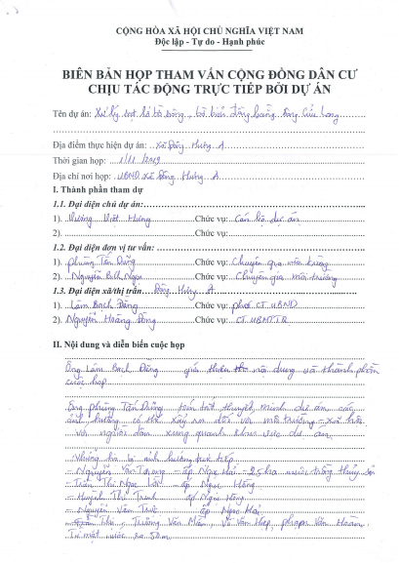
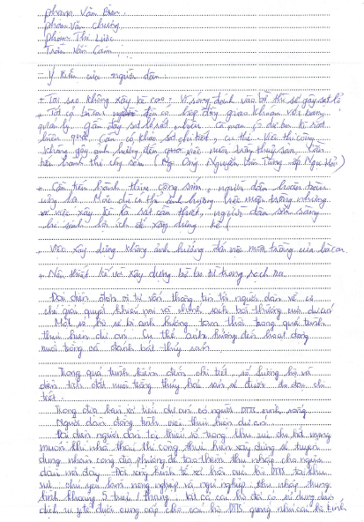
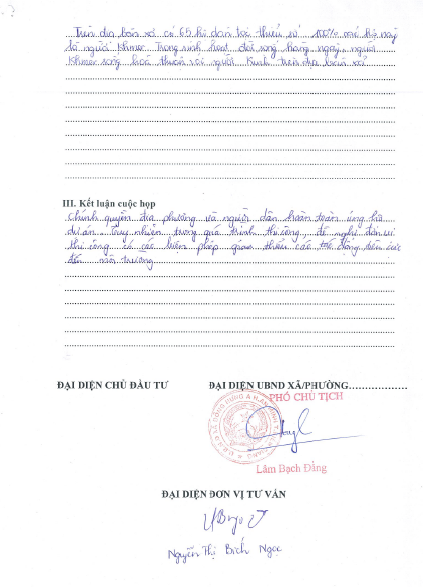
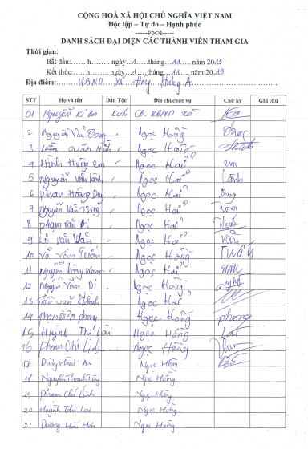
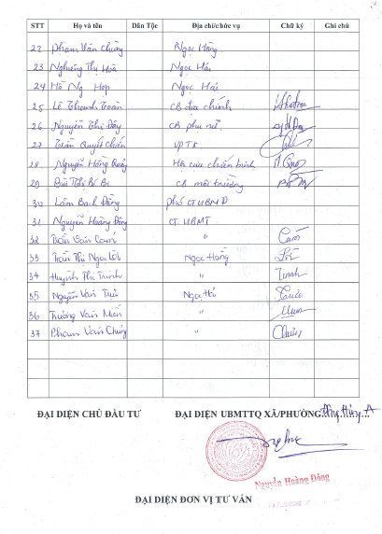

2/ Van Khanh Dong commune
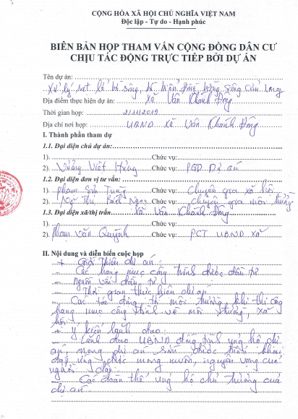
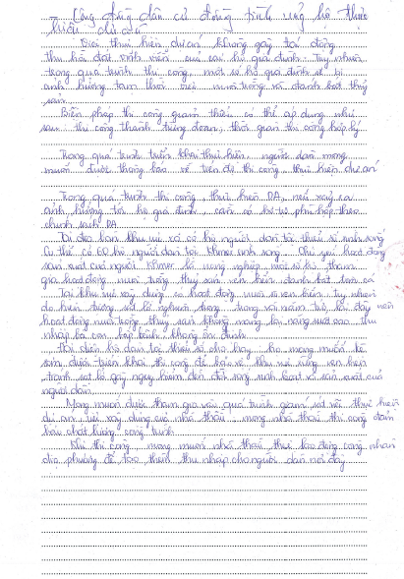
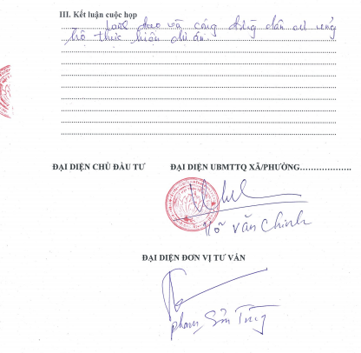

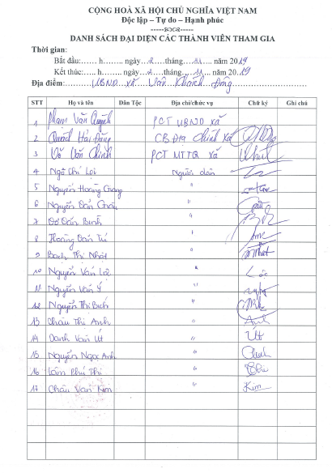
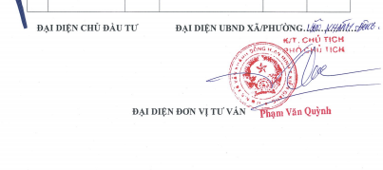

3/ Tan Thanh commune
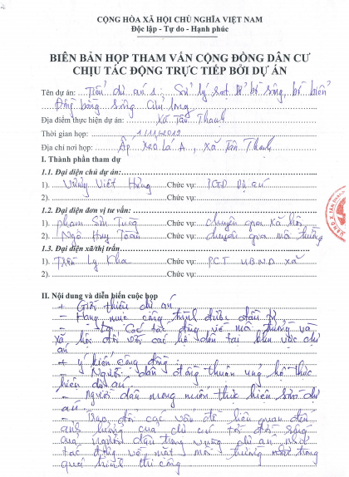
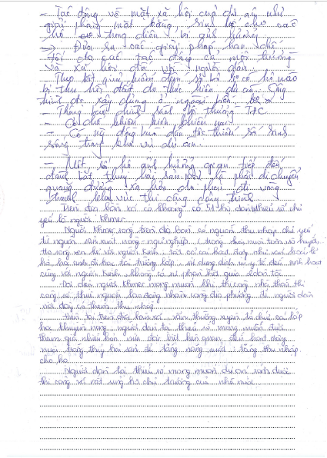

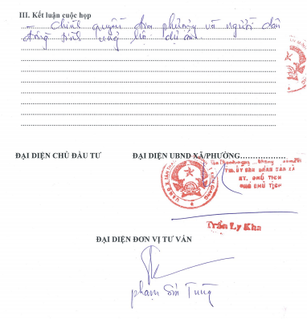
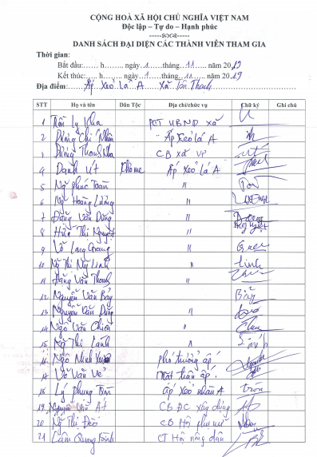
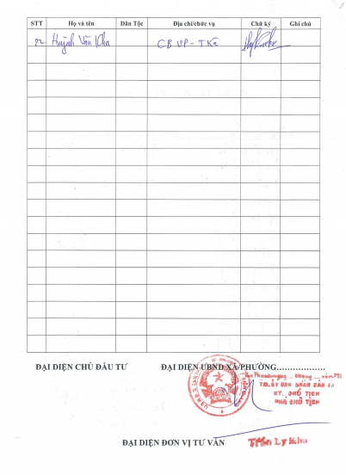

Annex 2: Project Information Booklet
(draft)
Introduction:
The Government of Vietnam has received a credit of the International Development Association (IDA) to finance the Mekong Delta Integrated Climate Resilience and Sustainable Livelihoods Project (MD-ICRSL Project). Subproject 01: "Addressing Coastal and Riverbank Erosion in Mekong Delta - Kien Giang Province" is part of Component 2 - Managing Upstream Floods - Mekong Delta Integrated Climate Resilience and Sustainable Livelihoods Project (MD-ICRSL Project).
Objective of the subproject
- General objectives: Overcoming erosion of river and coastal banks, protecting coastal population, infrastructure and land, enabling livelihoods stabilization and development, and improving incomes for people in the subproject area.
- Specific objectives: Eradicating erosion at selected critical (emergency) locations, promoting land and water management better and improving disaster resilience under climate change and sea level rise conditions in selected provinces in the Mekong Delta.
Components of the subproject
Subproject 1: "Addressing Coastal and Riverbank Erosion in Mekong Delta - Kien Giang Province" is proposed to build an "Embankment against landslides in Xeo Nhau area, An Minh district". The work will cover 03 communes: Tan Thanh, Dong Hung A and Van Khanh Dong, in An Minh district.
According to preliminary estimates, the "Embankment against landslides in Xeo Nhau area, An Minh district" will directly protect 3,106 people and indirectly protect 14,319 people. Expectedly, about 493.5 ha of forest area are protected and 220 ha of forest will be restored; about 286 ha of productive land is directly protected and 4,025.5 ha of forest land is indirectly protected. In addition, important infrastructure works will be upgraded like protection forests, sea dikes, infrastructure systems inside sea dykes and houses.
The embankment will be about 9.8km long (From Xeo Nhau canal - Muong Dao canal).
Impact scope
Surveys are underway to determine exact number of affected households. However, because the structures are built entirely out of the sea, there will be no significant land acquisition impact. It is anticipated that people’s farming and fishing activities are possibly affected.
Who are affected households (AHs)?
AHs are those who are living in the affected area at the date that the project is publicly announced. The cut-off-date for eligibility is the date of notification for land acquisition. Persons who encroach into the area after the cut-off-date will not be entitled to compensation or any other form of resettlement assistance.
What are the resettlement policies and principles of the Project for affected households?
The basic resettlement principles of the Project are:
a) All APs are entitled to be compensated for their lost assets, incomes and businesses at replacement cost, and provided with rehabilitation measures sufficient to assist them to improve or at least maintain their pre-project living standards, incomes and productive capacity.
b) Lack of legal rights to the assets lost will not prevent APs from entitlement to compensation.
c) Compensation for affected assets shall be provided at market rates.
d) Preparation of resettlement plans and their implementation is to be carried out with participation and consultation of affected people.
e) The compensation of assets and relocation of affected households must be completed before commencing any construction activities.
f) Specific supports will be provided to ethnic minority, female headed households, households with disable people and other vulnerable households.
Detailed Measurement Survey (DMS)
The DMS will only be carried out in the presence of the AHs. AHs will be informed prior to the survey.
Subproject schedule
When other consultations will take place?
Consultations with AHs will continue during the detailed design phase and before the DMS. AHs will receive written invitations to join public meetings.
If there are disagreements or problems arising during the subproject implementation such as subproject-related compensation or disputes, do I have the right to complain?
Any AHs may file complaints or grievances. The subproject includes a Grievance Redress Process and AHs may present their complaints to the concerned local administrative officials and RCs, either verbally or in writing.
A complaint can be filed at first at the commune level and elevated to the highest provincial level if the AH is not satisfied with the decisions made by the respective commune or district. AHs will be exempted from all taxes and administrative and legal fees associated with filing and resolving disputes.
Any questions or concerns about the project, please contact: The Irrigation Projects Central Management Office.
Address: 23 Hang Tre, Hoan Kiem, Ha Noi
Tel.: 04.38253921
Email: info@cpo.vn
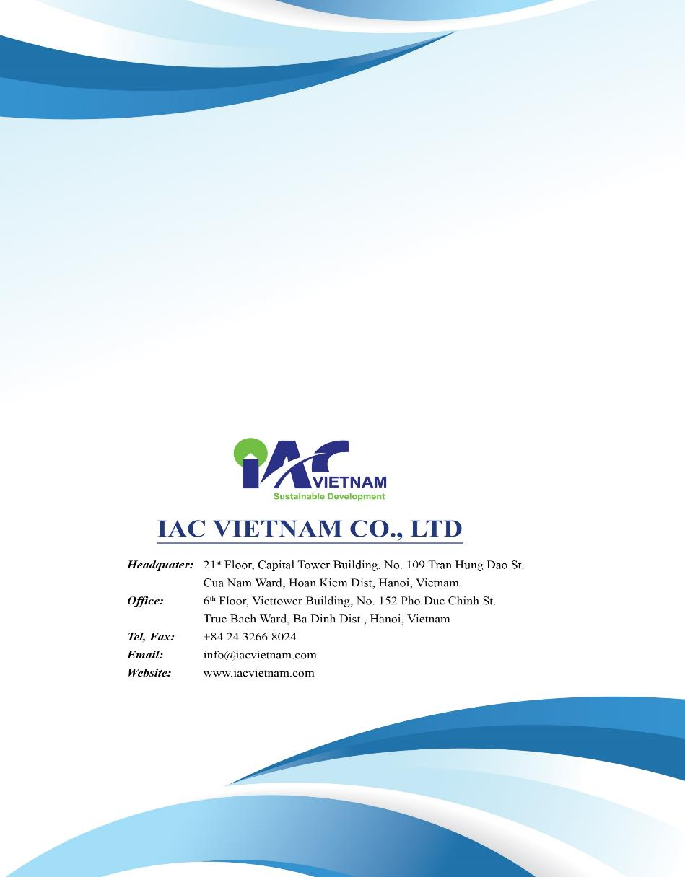

Covered under commune budget

